### Project Name: Job Application Tracking System - (Developer)

### Team ID : LTVIP2024TMID11609

### Team Leader : S MOHAN

Team member : K BALACHANDRA

### Dashboard

**Create A Dashboard**

1. Click the Dashboards tab.
2. Click New Dashboard.
3. Name the dashboard Job application wtih candidate name and click Create.
4. Click +Component.
5. Select the Job application wtih candidate name and click Select.
6. Select the Gauge chart and click Add.
7. Click Save and then Done.

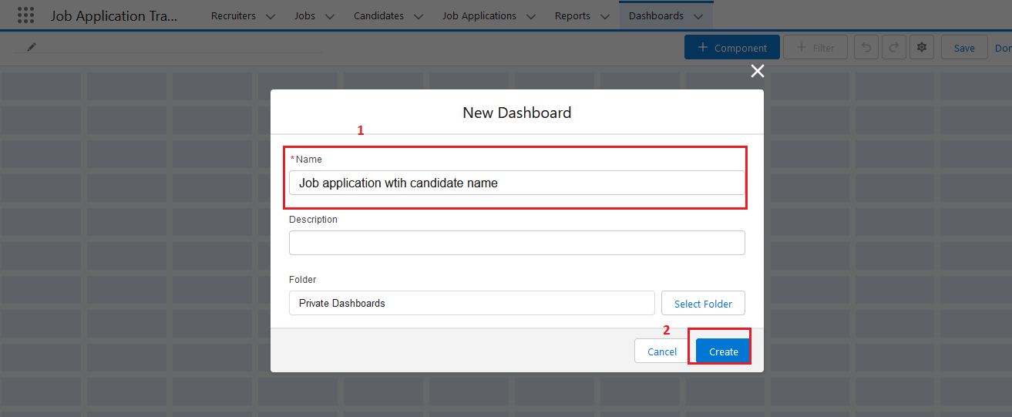  
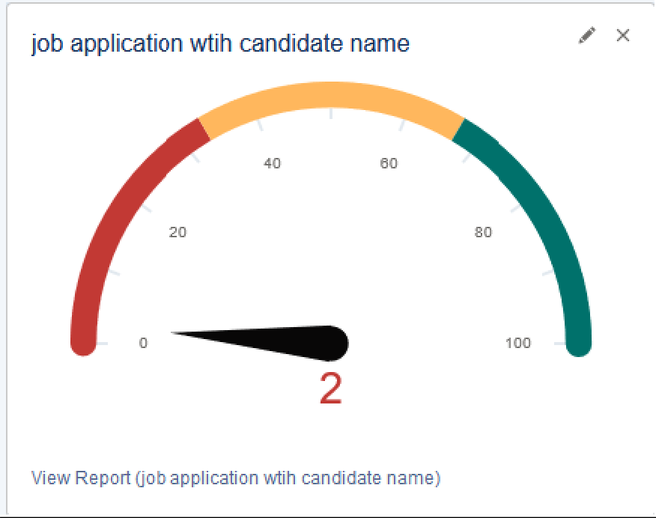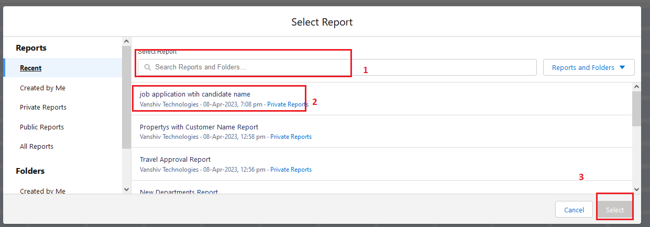

### View Report And Dashboard

**Report**

* Click on App Launcher on left side of screen.
* Search Job Application & click on it.
* Click on Reports Tab.
* Click on [job application wtih candidate name](https://vanshivtechnologyprivatelim-dev-ed.develop.lightning.force.com/lightning/r/sObject/00O2w00000EeBxDEAV/view?queryScope=userFolders) & see records

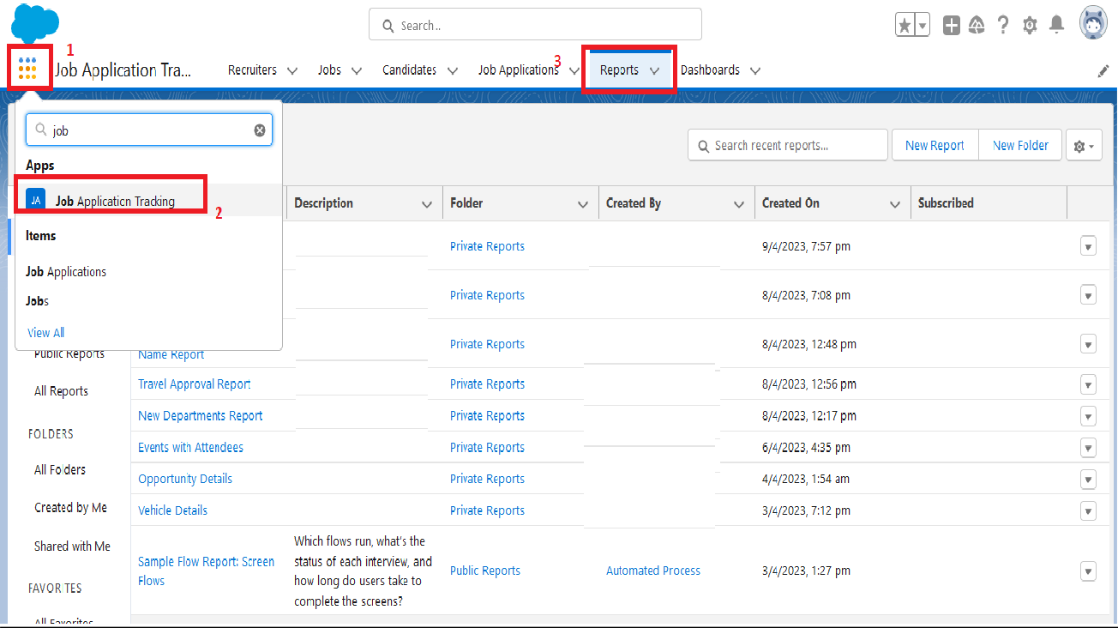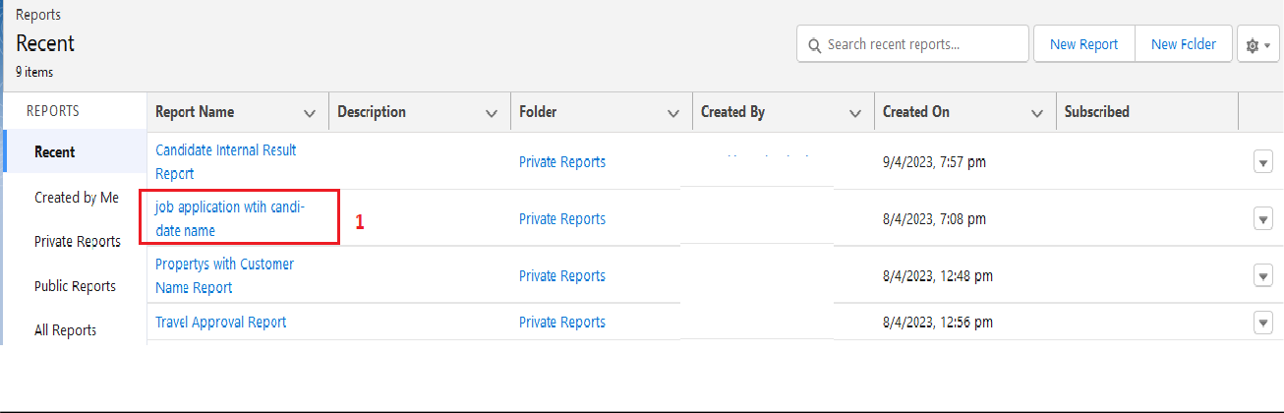  
  
  
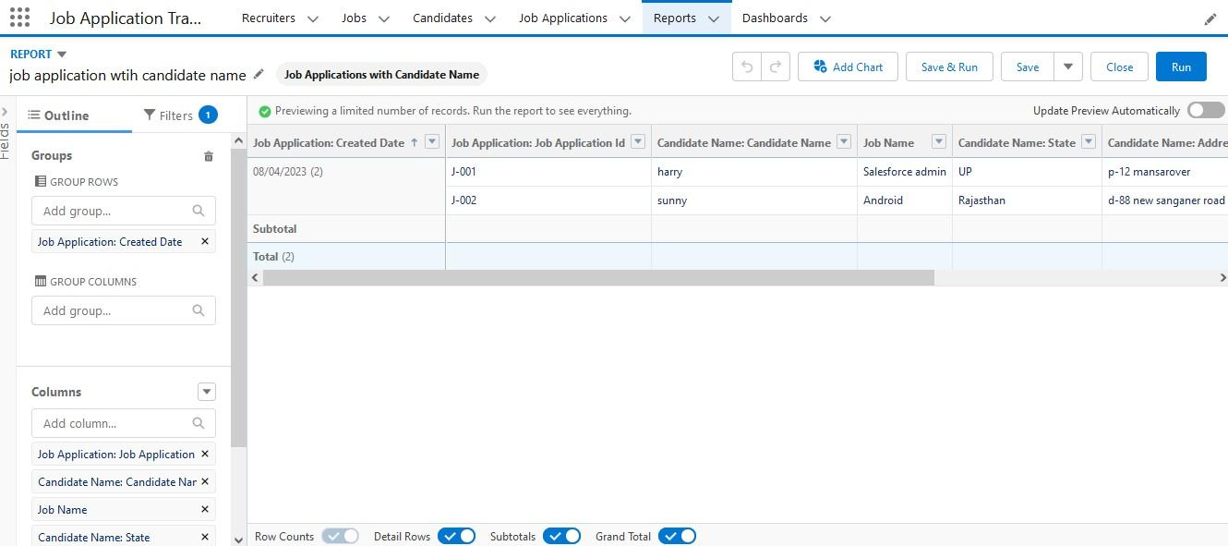

**Dashboard**

* Click on App Launcher on left side of screen.
* Search job application & click on it.
* Click on Dashboard Tab.
* Click on [job application wtih candidate name](https://vanshivtechnologyprivatelim-dev-ed.develop.lightning.force.com/lightning/r/sObject/00O2w00000EeBxDEAV/view?queryScope=userFolders) & see records

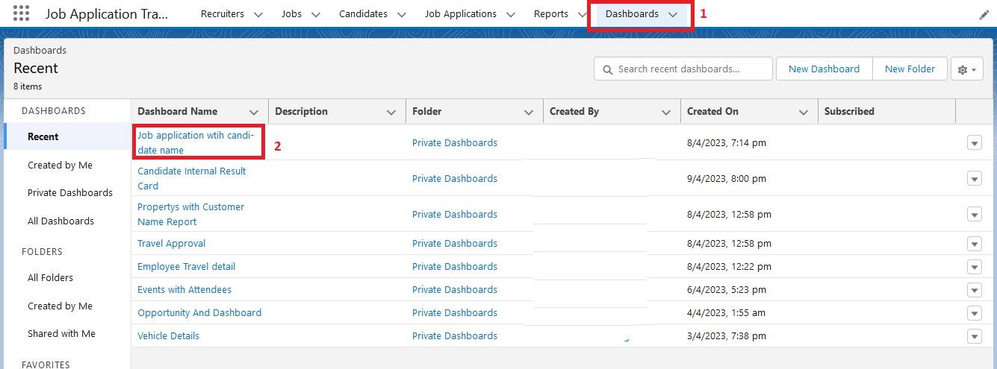

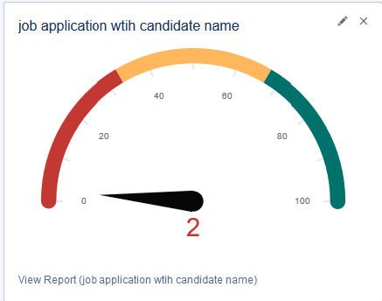

### Flows

**Create A Record Trigger Flow On Job Object**

1. Click on Gear icon and select setup
2. In Quick find Box enter flow and select the flows
3. Click on New flow and Select Record triggered Flows.

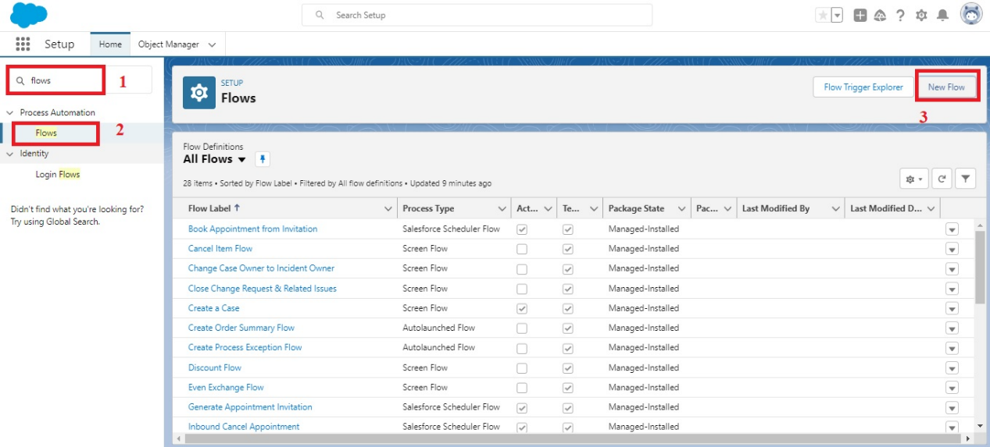  
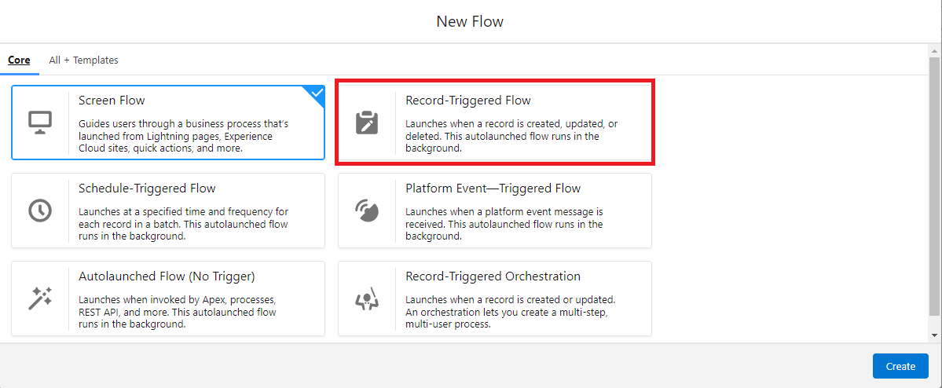

1. In the search bar type job and click done.

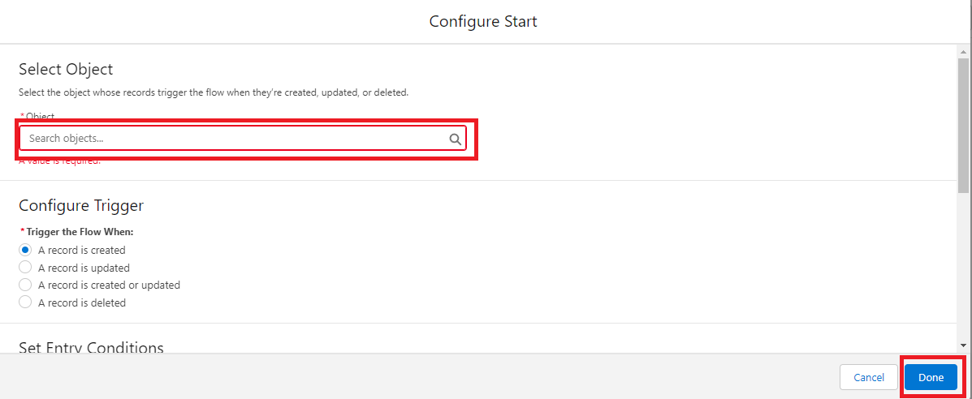

1. Add an element called Get record .
2. Label name as Recruiter  Records.
3. Select the object as Recruiter.
4. After entering the object follow the steps .
5. Conditional requirements should be all conditions are met ( AND ).
6. Select the field as Recruiter_Email__c.
7. Operation should be Is Null .
8. Value should be False. And click done.

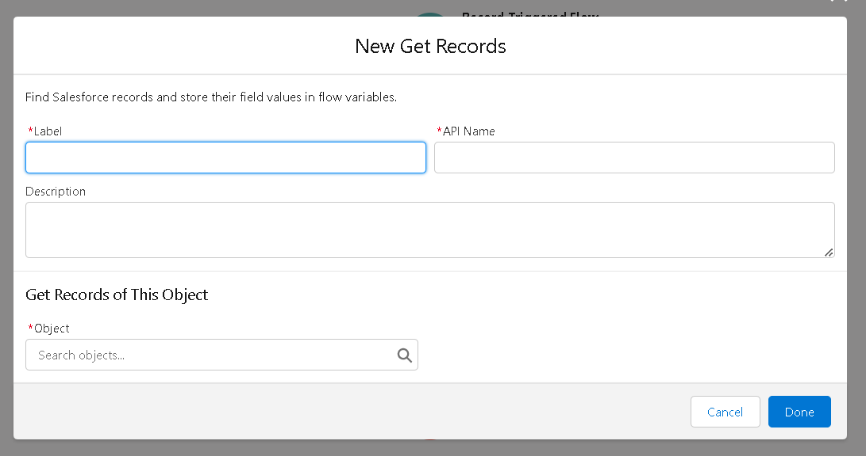

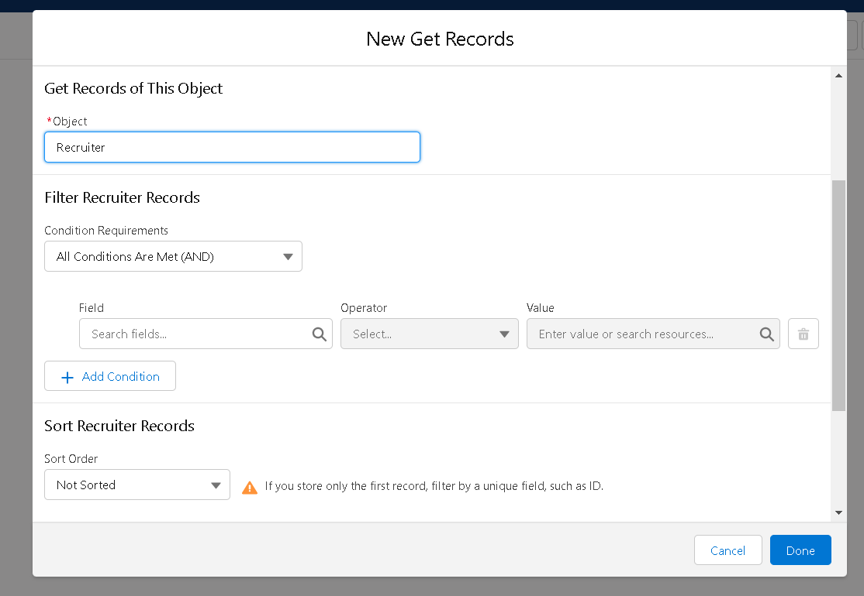

1. Add another element called Action.
2. Click on the Action and start creating new action .

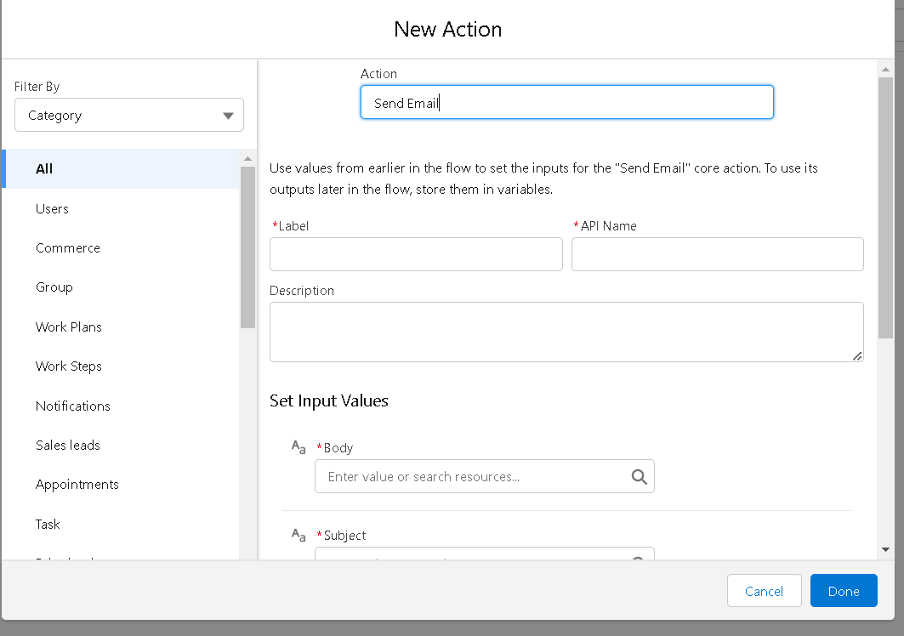

1. Select the action as Send Email .
2. Enter the label name job email, API name is auto populated .
3. Set input values as

              a. Body : {!$Record.Name} with {!$Record.Job_Application_Id__c} is available. Please find the suitable candidates      for the position.

     b. Subject : {!$Record.Name}

1. Recipient Email Addresses (comma-separated) should be included for that turn it on.
   1. Recipient Email Addresses : {!$Record.Recruiter_Name__r.Recruiter_Email__c}

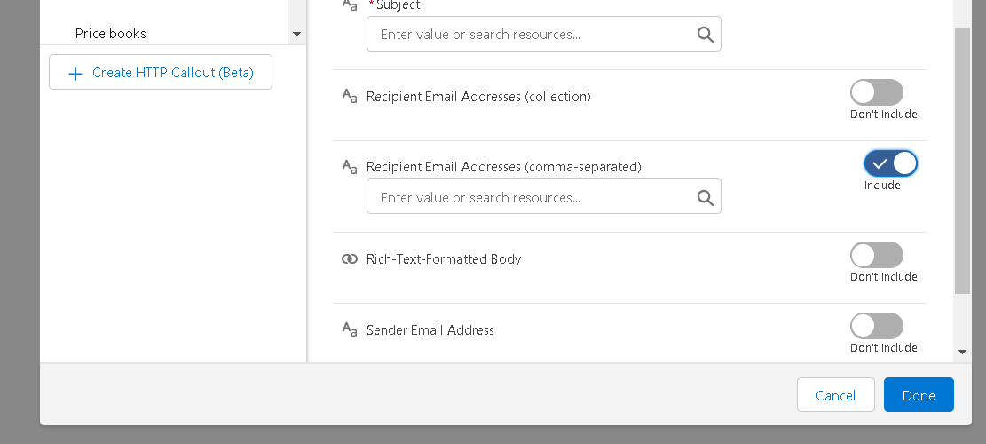

1. Click on done .
2. After the completion of flow,  check whether the flow is running and click save .
3. And Activate the flow .

**Create Another Flow**

1. Click on Gear icon and select setup
2. In Quick find Box enter flow and select the flows
3. Click on New flow and Select Screen Flows.

  
  


1. Add an element called screen .
2. Screen label should be Candidate details.
3. API name is auto populated.
4. Add the components in canvas .
5. Select the text from the components .
6. Label name as Candidate name.
7. API name is auto populated.
8. Select the text area from the components.
9. Label name as Address.
10. API name is auto populated.
11. Select the email from the components.
12. Label name as Email.
13. API name is auto populated.
14. Select the Phone from the components.
15. Label name as Phone.
16. API name is auto populated.
17. Select the picklist from the components.
18. Label name as Education.
19. API name is auto populated.
20. And select the choice as {!pick}.
21. Add a header to the canvas candidate flow for job application .
22. Click on save.

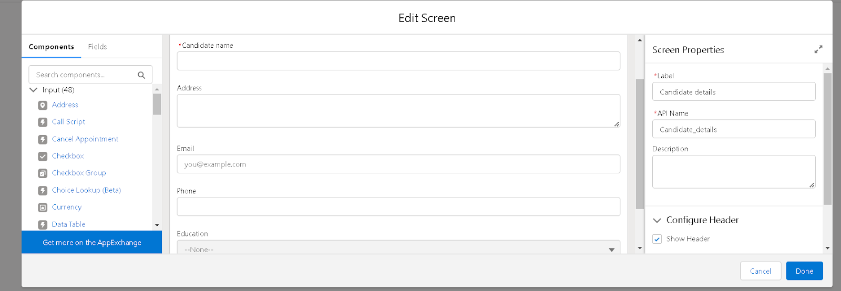

1. Next , add another element called create record .
2. Label name should be Create candidate record.
3. API is auto populated . and change the How to Set the Record Fields  to Use separate resources, and literal values.
4. Select the object  Candidate1.

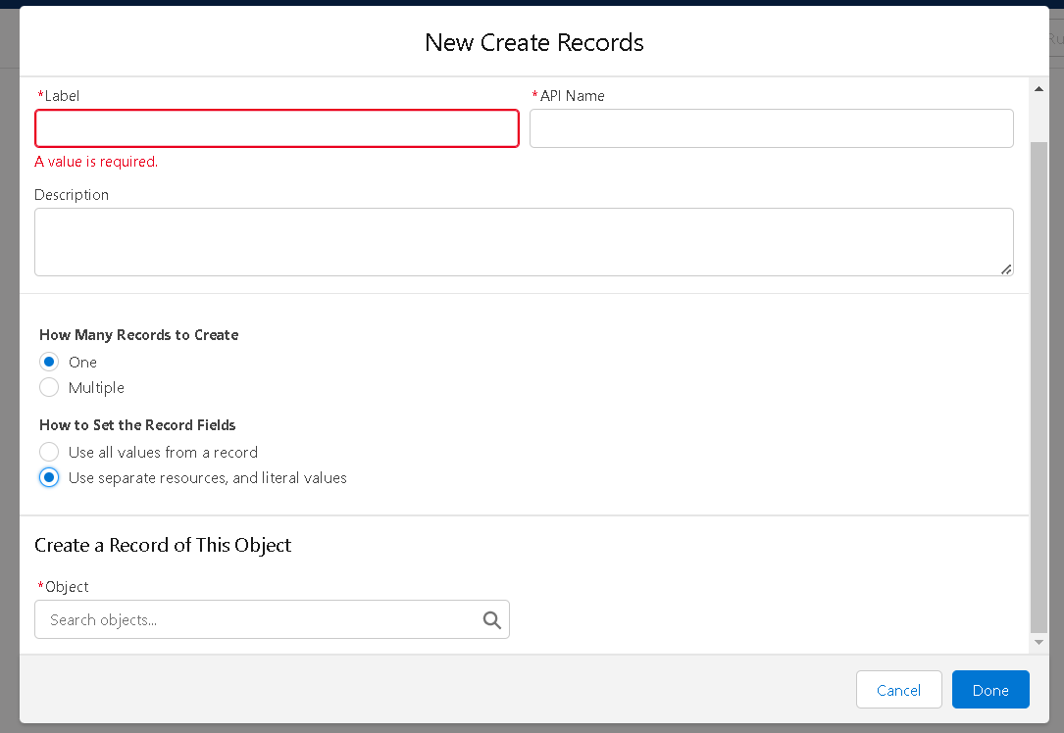

1. Set the values for the candidate1 as
   1. Field is Address__c and value should be {!Address}.
   2. Field is Education__c and value should be {!Education}.
   3. Field is Email__c and value should be {!Email.value}.
   4. Field is Name and value should be {!Candidate_name}.
2. After that click on done.

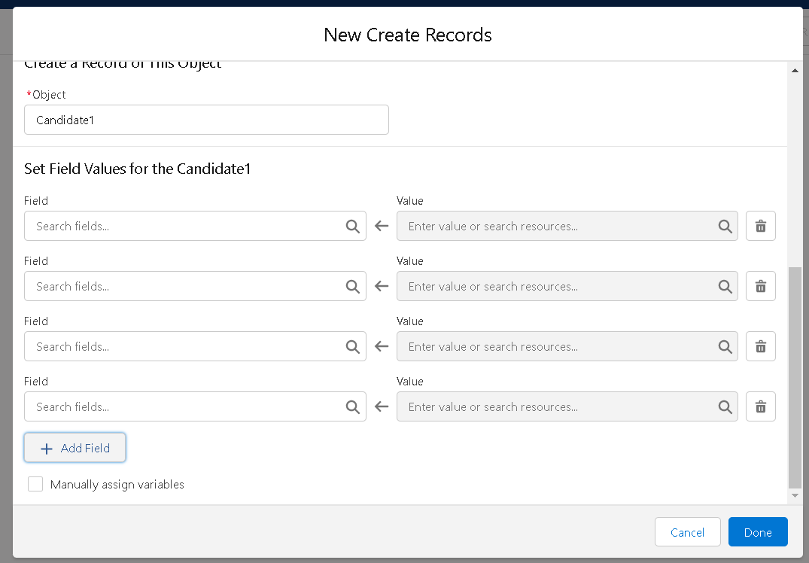

1. Run the flow and check whether the flow is working and click on save.
2. And activate the flow.